1. Consider a simple UDP-based protocol for requesting files. The client sends an initial file request, and the server answers (if the file can be sent) with the first data packet. Client and server then continue with a stop-and-wait transmission mechanism.

(a) Describe a scenario by which a client might request one file but get another; you may allow the client application to exit abruptly and be restarted with the same port.

(b) Propose a change in the protocol that will make this situation much less likely.

2. You are hired to design a reliable byte-stream protocol that uses a sliding window (like TCP). This protocol will run over a 1-Gbps network. The RTT of the network is 100 ms, and the maximum segment lifetime is 30 seconds.

(a) How many bits would you include in the AdvertisedWindow and SequenceNum fields of your protocol header?

(b) How would you determine the numbers given above, and which values might be less certain?

3. Suppose a host wants to establish the reliability of a link by sending packets and measuring the percentage that is received; routers, for example, do this. Explain the difficulty doing this over a TCP connection. (Think if this affect your implementation of PA3).

4. Suppose TCP operates over a 1-Gbps link. Assuming TCP could utilize the full bandwidth continuously, how long would it take the sequence numbers to wrap around completely?

5. Host A and B are directly connected with a 100 Mbps link. There is one TCP connection between the two hosts, and Host A is sending to Host B an enormous file over this connection. Host A can send its application data into its TCP socket at a rate as high as 120 Mbps but Host B can read out of its TCP receive buffer at a maximum rate of 50 Mbps. Describe the effect of TCP flow control.

6. True or false?

• The size of the TCP rwnd never changes throughout the duration of the connection. • Suppose Host A is sending Host B a large file over a TCP connection. The number of unacknowledged bytes that A sends cannot exceed the size of the receive buffer. • The TCP segment has a field in its header for rwnd.

7. Describe briefly how loops in paths can be detected in BGP.

8. Consider the network shown below. Suppose AS3 and AS2 are running OSPF for their intra-AS routing protocol. Suppose AS1 and AS4 are running RIP for their intra-AS routing protocol. Suppose eBGP and iBGP are used for the inter-AS routing protocol. Initially suppose there is no physical link between AS2 and AS4.

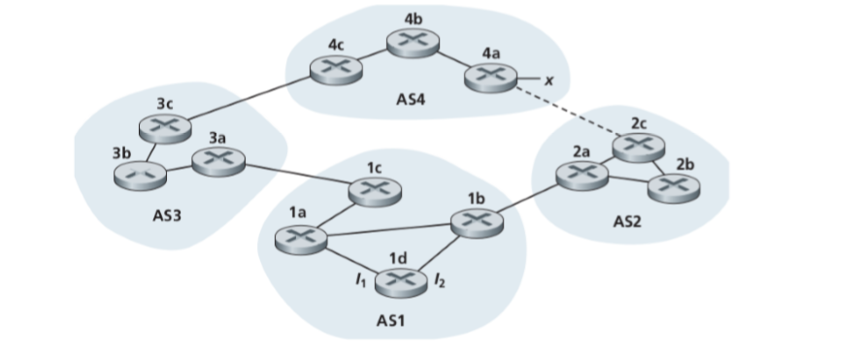

1. Router 3c learns about prefix x from which routing protocol: OSPF, RIPeBGP, or iBGP?

b. Router 3a learns about x from which routing protocol?

c. Router 1c learns about x from which routing protocol?

d. Router 1d learns about x from which routing protocol?

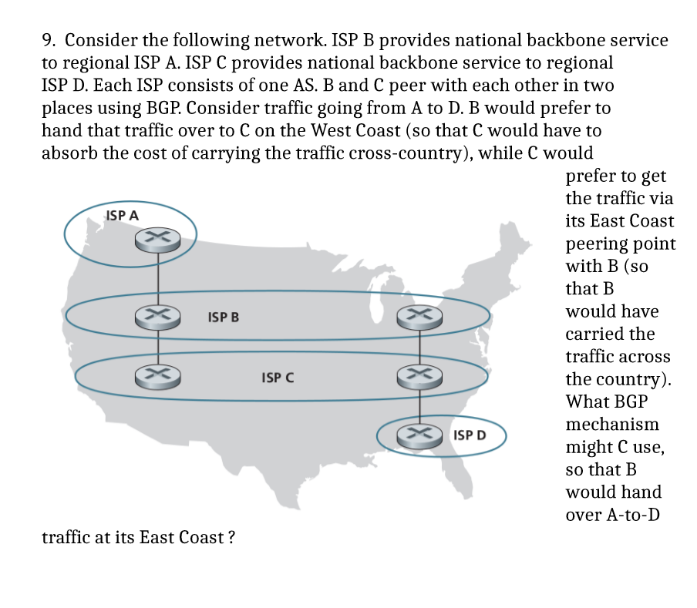

10. Suppose ASs X and Z are not directly connected but instead are connected by AS Y. Further suppose that X has a peering agreement with Y, and that Y has a peering agreement with Z. Finally, suppose that Z wants to transit all of Y’s traffic but does not want to transit X’s traffic. Does BGP allow Z to implement this policy? (hint: draw the graph first)